Software Design Document
<Project Title>



Submitted by
Student Name: Zubia Hameed
Roll no: F22BINFT1E02139
Submitted to
Mam Sara fareed

Department of Information Technology
Faculty of Computing
The Islamia University of Bahawalpur

Summery
CHAPTER 4
SOFTWARE
DESIGN DOCUMENT

4.1 Introduction
This chapter presents the Software Design Document (SDD) of the Learning Management System (LMS) developed as a Final Year Project. The purpose of this chapter is to describe the overall system design derived from the approved Software Requirement Specification (SRS). It explains how system requirements are transformed into architectural components, database structures, and user interfaces. This chapter serves as a blueprint for developers and evaluators to understand the internal working and design decisions of the LMS.
4.2 System Overview
The Learning Management System is designed to automate and manage academic and administrative processes within an educational institution. The system provides functionalities such as user management, semester handling, course offerings, student enrollment, event management, and report generation. The LMS supports multiple user roles including Administrator, Instructor, and Student, each having specific permissions and responsibilities. The system ensures secure access, data integrity, and efficient academic management.
4.3 System Architecture
The LMS follows a three-tier layered architecture integrated with the Model–View–Controller (MVC) design pattern. This architectural approach improves modularity, scalability, and maintainability of the system by separating responsibilities into logical layers.
4.3.1 Architectural Layers
Layer
Description
Presentation Layer
Handles user interaction and interface rendering
Application Logic Layer
Contains business logic and system workflows
Data Layer
Manages database operations and persistent storage
Each layer communicates with adjacent layers through defined interfaces, ensuring loose coupling and structured system flow.
4.4 Presentation Layer Design
The presentation layer represents the user-facing part of the LMS. It is responsible for displaying information and collecting user input.
Technologies Used:
HTML5
CSS3
Bootstrap
React
Key Features:
Role-based dashboards (Admin, Student, Instructor)
Responsive design for desktop and mobile devices
Consistent layout and navigation
Responsibilities:
Display login and authentication screens
Render dashboards with academic data
Collect user inputs through forms
Perform basic client-side validation
The presentation layer does not contain any business logic.
4.5 Application Logic Layer Design
The application logic layer acts as the core processing unit of the LMS. It contains all system rules, validations, and workflows.
Technology Used:
PHP with Laravel Framework
4.5.1 Controllers Description
Controller
Function
AuthController
Handles login, logout, authentication, and role-based access
UserController
Manages user registration, updates, deletion, and roles
CourseController
Controls course creation, offering, and enrollment
SemesterController
Manages semester creation, scheduling, and freezing
EventController
Handles academic events management
ReportController
Generates academic and analytical reports
Each controller enforces rules defined in the SRS before interacting with the database.
4.6 Data Layer Design
The data layer is responsible for storing and retrieving system data.
Technology Used:
MariaDB (Relational Database)
Design Principles:
Fully normalized database schema
Referential integrity using primary and foreign keys
Secure data access through ORM
No direct database access from the user interface
The data layer ensures consistency, accuracy, and secure storage of academic records.
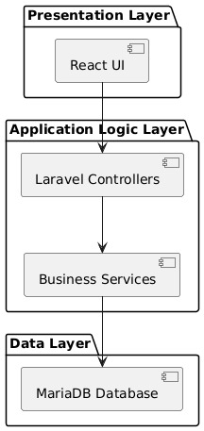
4.7 UML Diagrams
UML diagrams are used to visually represent the system design and interactions.
4.7.1 Use Case Diagram
The use case diagram illustrates interactions between system actors and the LMS.
Actors:
Administrator
Instructor
Student
Major Use Cases:
Login / Logout
Manage Users
Create Semester
Offer Courses
Enroll in Courses
Manage Events
View Reports
Freeze Semester
4.7.2 Class Diagram
The class diagram represents the static structure of the LMS.
Main Classes:
User
Course
Semester
Enrollment
Event
Report
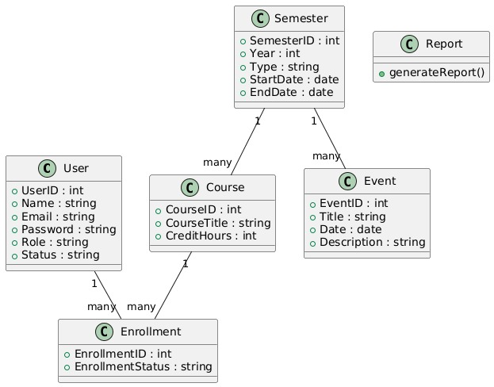

Relationships:
One User can have multiple Enrollments
One Course can have many Enrollments
One Semester can offer multiple Courses
4.7.3 Sequence Diagram
The sequence diagram shows time-based interactions between system components.
Example: Course Enrollment Process
Student submits enrollment request
System validates semester status
Course capacity and clashes are checked
Enrollment is stored in database
Confirmation is returned to the student
4.8 Database Design
The LMS database is designed using a normalized relational model.
4.8.1 Entity Description
Entity
Primary Key
Attributes
User
UserID
Name, Email, Password, Role, Status
Course
CourseID
CourseTitle, CreditHours, SemesterID
Semester
SemesterID
Year, Type, StartDate, EndDate
Enrollment
EnrollmentID
UserID, CourseID, Status
Event
EventID
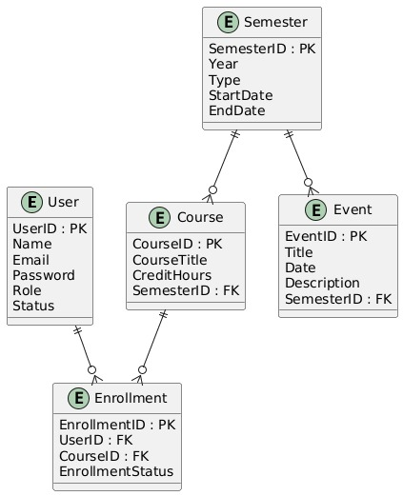

Title, Date, Description
This design supports scalability and maintains data integrity.
4.9 User Interface Design
The user interface is designed with a focus on usability and accessibility.
Design Principles:
Clean and minimal layout
High readability
Consistent navigation
Accessibility-focused
4.9.1 Screens Description
Screen
Description
Login Page
Secure authentication
Admin Dashboard
User, course, and semester management
Student Dashboard
Enrollment, timetable, events
Instructor Dashboard
Course content and attendance
Reports Page
Academic reports
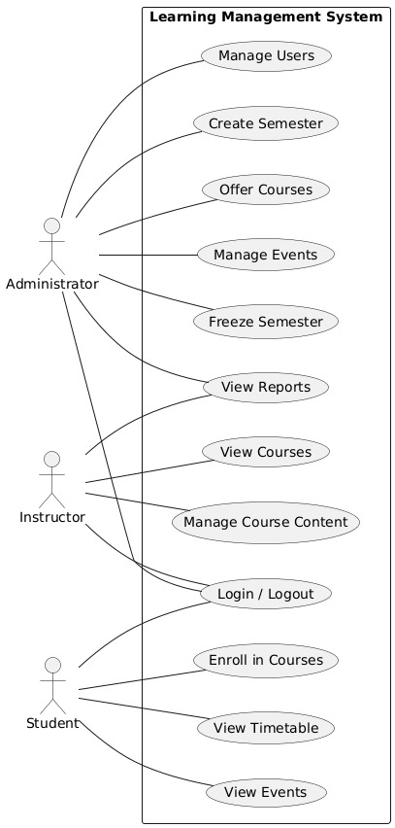
4.10 Design Constraints and Standards
MVC architecture compliance
Secure authentication mechanisms
Role-based access control
Modular and extensible code structure
Error handling and logging
Academic documentation standards compliance
4.11 Conclusion
This chapter presented the complete software design of the Learning Management System. The design ensures that the system is secure, scalable, maintainable, and aligned with the requirements specified in the SRS. The detailed architectural design, UML diagrams, database schema, and user interface layout provide a solid foundation for system implementation and future enhancements.

- Application Architecture
Authors will explain the architecture of overall application. If they are following a pattern like MVC or MVVM then they will also explain the components of architecture (list of proposed Models, Views and Controllers). Further they explain the controllers and also provide the list of function of controllers but they will not explain Models and Views. If some APIs are developing then they will also explain these and if they are calling some external APIs or libraries then they also explain the working of these APIs and libraries.
They can provide class diagrams, sequence diagrams and other UML diagrams to explain the proposed working of their system. Furthermore, they will also provide the coding conventions they use to write the application
- Data Model Schema
Detail of database conceptual schema will be provided here. Each data model entity will be explained in details, its working properties and relationship with other entities. Authors will also provide ER diagram to explain the working entities.

- User Interface
Overall design philosophy such as color scheme, font, design niche and screen constraints (if required then responsiveness or targeted screens size) will be discussed here. List of screens/pages will be provided and explain the data on each page/screen. List of controls (Textbox, Drop Down, Buttons etc.) on each page will be provided and explain the working of data. Also explain the input constraints.
